|  |  |  |
| --- | --- | --- |
| **I** | **Angle Calculation** | **Time Limit:**  **1 sec** |

Techboy is watching the Quarter Final Match, Brazil vs. Belgium, of FIFA WORLD CUP 2018 on TV. At 90th minute, Neymar is being fouled. Brazil gets a free kick so they are trying to win the match by a "last-minute goal". Before taking the free kick Neymar, Coutinho, Willian is taking position. In our problem, Player **A** is Neymar, player **B** is Willian & player **C** is Coutinho. **E** is not any player, he is the referee! Techboy takes a pen and a paper, and draws the position of the players and referee as points and connects some of them. He gets the following figure.

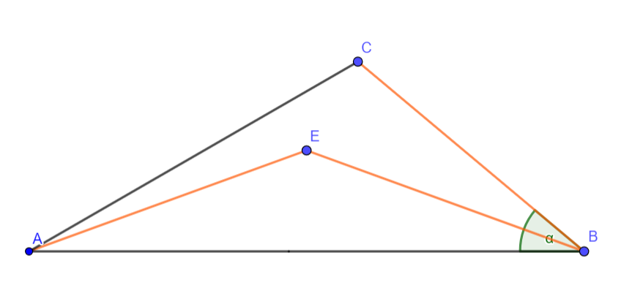

Techboy knows that the distance between Neymar to Referee is **AE**, Willian to Referee is **BE** and Willian to Coutinho is **BC** which are same. The angle between Neymar-Willian-Coutinho which is $∠ABC$ and the angle between Referee-Neymar-Coutinho is $∠EAC$. **BE** divides $∠ABC$ into half. Given $∠ABC$, can you help Techboy to find $∠EAC$?

**Input**

The first line of the input is an integer **T (1 <= T <= 50) denoting the test case**. The next **T** lines contain a single integer **X (20 <= X <=70)** denoting the angle described in the problem.

**Output**

There will be **T** lines of output in the form of “**Case X: Y**”, where **X** is the case number and **Y** is the value of $∠EAC$ which has two digits after the decimal point. See the sample I/O.

**Sample I/O**

|  |  |
| --- | --- |
| Input | Output |
| 2  40  50 | Case 1: 10.00  Case 2: 8.22 |